H.3.16 Mobile PC Upload/Download Utility (MOBPCUD)

Intended Use
Use this screen to download and upload donor data so that mobile blood drives can access donor data without a network connection to the Blood Centers application. Specifically, you can:
download donor data from the Blood Centers application server to a mobile site master laptop upload donor data from a mobile site master laptop to the Blood Centers application server
Donor data can be downloaded from the Blood Centers application server to a mobile site master laptop. This data contains complete donor information to identify uniqueness of donor, eligibility, deferrals (interdictions), and historical donation/deferral data including previous answers to health history questions. With this downloaded data, the On-Site Registration module is fully functional at the mobile site, and can perform all the registration and donation (or deferral) donor activities offline.
The donor data collected offline at the mobile site can then be uploaded from the mobile site master laptop to the Blood Centers application server. The upload from the mobile master laptop to the Blood Centers application server will contain registration and donation (or deferral) data, and provides complete documentation of the donation and deferral processes managed within the On-Site Registration Module.
Up to a maximum of six laptops can be connected to a master laptop, which functions as a server. The master laptop synchronizes data flow among laptops and enables the data update to the Blood Centers application server.

Limitations
Only data committed to the database can be downloaded to the laptop server.
The user may leave the screen while the host server executes the database upload. The status will continue to display as long as the user remains on the screen, but it will not display once the user logs out.

Prerequisites
A master laptop, which meets the minimum requirements for data download as established by WellSky, must be identified for downloads and uploads.
To maintain security and data integrity, all uploads and downloads should be performed via a secure and wired connection.
You must have sufficient administrative permissions to access the download and upload functionality. If you do not have sufficient permission, the option will not appear on the Blood Centers API menu.
Designate the directory on the hard drive of the master laptop where extracted donor data is stored by setting the master code APIDR.

Accessing the Screen
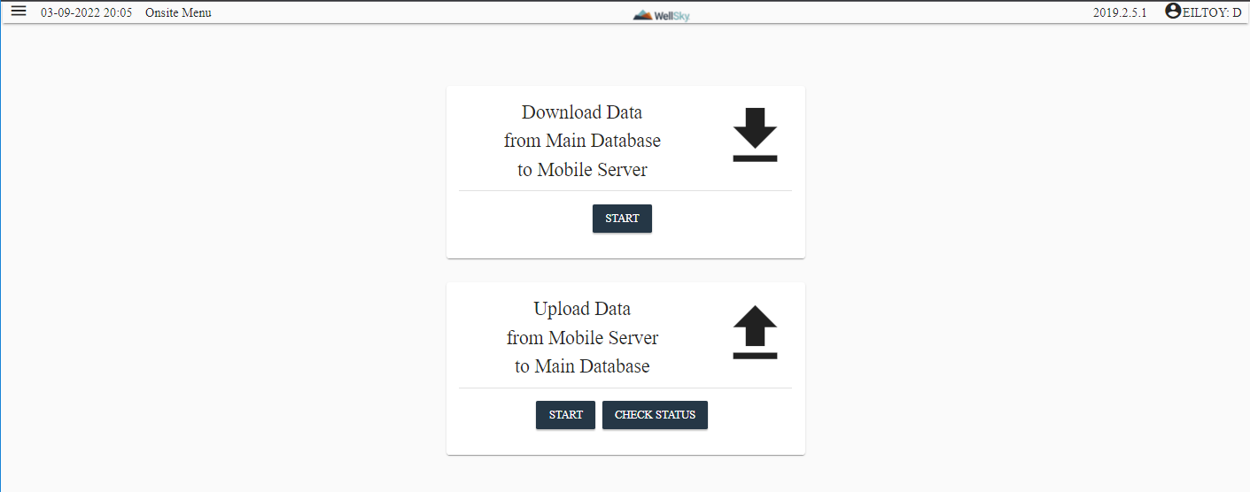

Access this screen from the On-Site Module menu or by clicking Mobile PC Upload/Download.

The Download Data from Main Database to Mobile Server Button


Important! Downloading data to the Mobile laptop overwrites all information in the local database on the Mobile laptop. It is recommended that you perform a data extraction on the Mobile laptop before performing the download.

The Donor application server runs a Cron job at established intervals (WellSky recommends once per day) to create a current database file that can be exported to the mobile site master laptop.
Perform the following steps to download the data from the Blood Centers application server to your mobile laptop:

NOTE – These directions are completed on the Mobile laptop that is accessing the production application.

      - On the Mobile PC Upload Download Utility screen, click Download Data to Mobile Laptop to initiate the download of donor data from the Blood Centers application server to the mobile site master laptop. The following warning displays:

- On the Mobile PC Upload Download screen, click the Start button in the Download Data from Main Database to Mobile Server box to initiate the download of donor data from the Blood Centers application server to the mobile site master laptop.

- The following message displays while the mobile download is in progress:

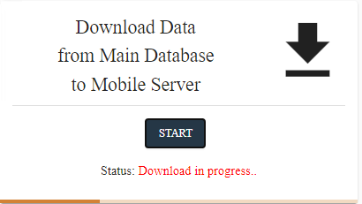

NOTE – Download time depends on your network bandwidth and the size of the files you are downloading.

- When the download is complete, the following message displays indicating download completed successfully.
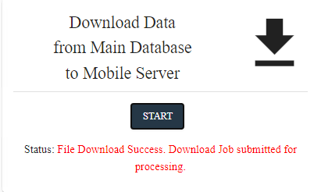

- Close the application and check the log files located at D:\lifetrak\replication\log directory to make sure that no errors occurred.
NOTE – Download is completed when all log files are updated with the current system time. Import_error.log file should be opened and verify there were no errors during download.

The Upload Data from Mobile Server to Main Database But ton
NOTE – These directions are completed on the mobile laptop that is accessing the production application.

After collecting donor data during the mobile drive, you must use the offline menu function to generate the files and extract the data that is then stored on the hard drive of the mobile laptop.

NOTE – For more information on extracting the donor data, see the Extract Data to File (EXTRACT) section.

The extracted data files are portable and can be copied to the extract directory on another mobile master laptop prior to upload, if needed. The size of the data file will vary, depending on the amount of donor information collected during the mobile drive.
On the Mobile PC Upload Download Utility screen, click Upload Data to from Mobile Laptop to Blood Centers Application to initiate the upload of donor data from the mobile site master laptop to the Blood Centers application server. A confirmation message appears when the upload is complete.
- On the Mobile PC Upload Download screen, click Start in the Upload Data from Mobile Server to Main Database box to initiate the upload of donor data from the mobile site master laptop to the Blood Centers application server.
- The File Open screen is displayed, select the .zip file that was extracted
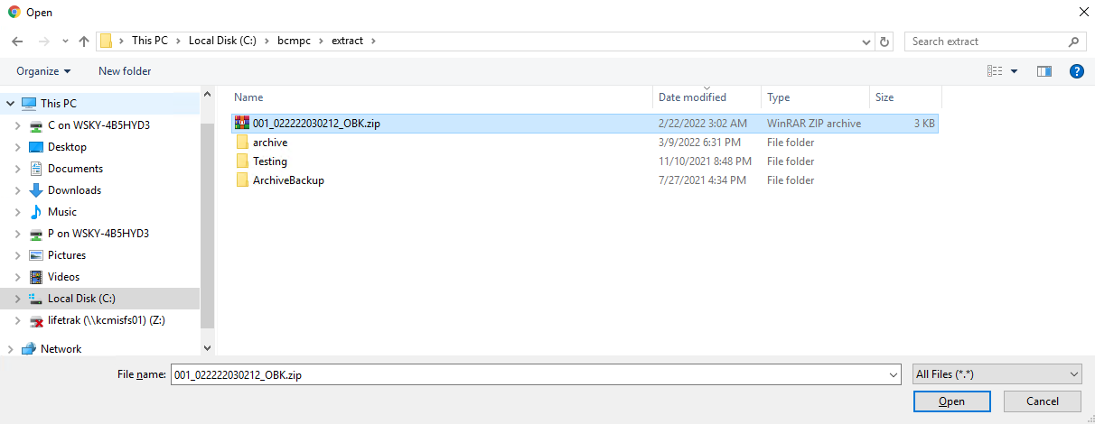

- Press Open button on the File Open screen.
- When the upload is complete, the following message displays indicating upload process is completed successfully.
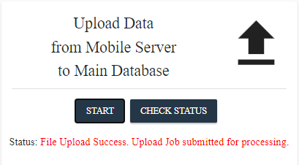

The Donor application server runs a Cron job at established intervals (WellSky recommends once per day) to upload the data from the mobile database to the master laptop.

NOTE – An error message displays if the system cannot complete the upload.
NOTE – Perform an API Log Query to verify if the upload was complete or if there were errors. See Blood Centers API Log Query (APILOG) in this Chapter for more information.

The Check Status But ton
The Check Status button in the Upload Data from Mobile Server to Main Database box displays the status of the uploads for the current day and the day prior. Online ID is displayed in the status list after the .zip file is selected and uploaded successfully.
- In Queue Status – The extract file is displayed with a status of In Queue after the .zip file is uploaded but before the Cron job is completed for the file.

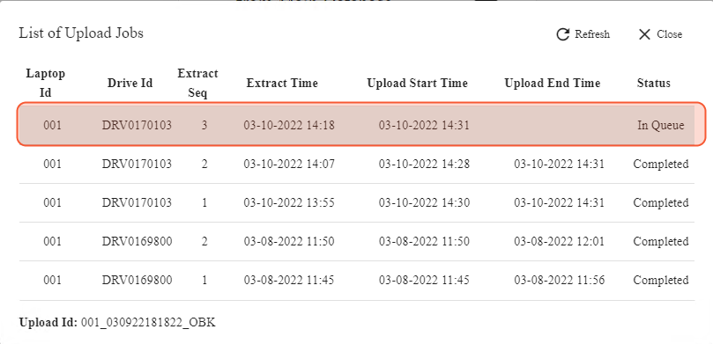
- Completed Status – The extract file is displayed with a status of Completed after the .zip file is uploaded and the data is in the main database after the mobile upload Cron job is completed:
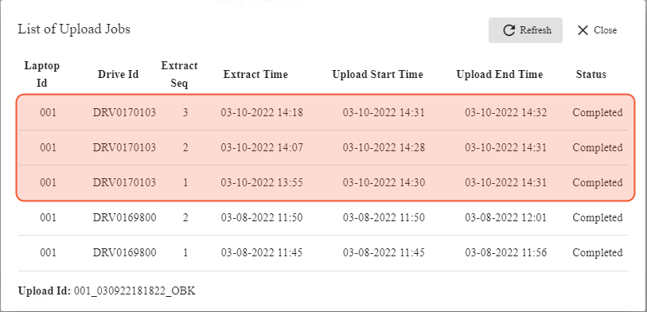

Recommendations
The following are recommended:
Downloads from the application server to laptops should be performed during non-peak times.
To ensure that all current data are included in the Cron job data file, make sure that all daily collections/deferral updates are committed to the database before the Cron job's scheduled run time.
To make sure that the information available at your mobile site is most current, perform the download at the latest possible time before a drive. If you are uncertain whether or not current data has been downloaded, perform a download.
If you are uncertain whether or not data has been uploaded from the mobile laptop server to the Blood Centers application server, perform an upload. Only new data is transferred to the Donor database during an upload. If an upload has already occurred, a second upload will not adversely affect the database.
If you are uncertain whether or not data has been uploaded from the mobile laptop server to the Blood Centers application server, check to see if there are any .zip files that were extracted in the extract folder. Upload any .zip files not already uploaded to the main database.

At Commit
At download, a current copy of the Donor database is placed on a laptop server, enabling mobile drive staff to use existing and collect new donor data for a drive without accessing the network. The download is date and time stamped in the Donor database.
At upload, a copy of the data collected by staff during a mobile drive is uploaded to the Blood Centers application server, updating the Donor database.

What to Do Next
There is no next step.

